HIVE DOCUMENTATION

- To create a database
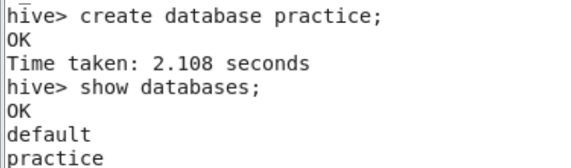

2.To create a table

3.To get the the description of the table use describe command
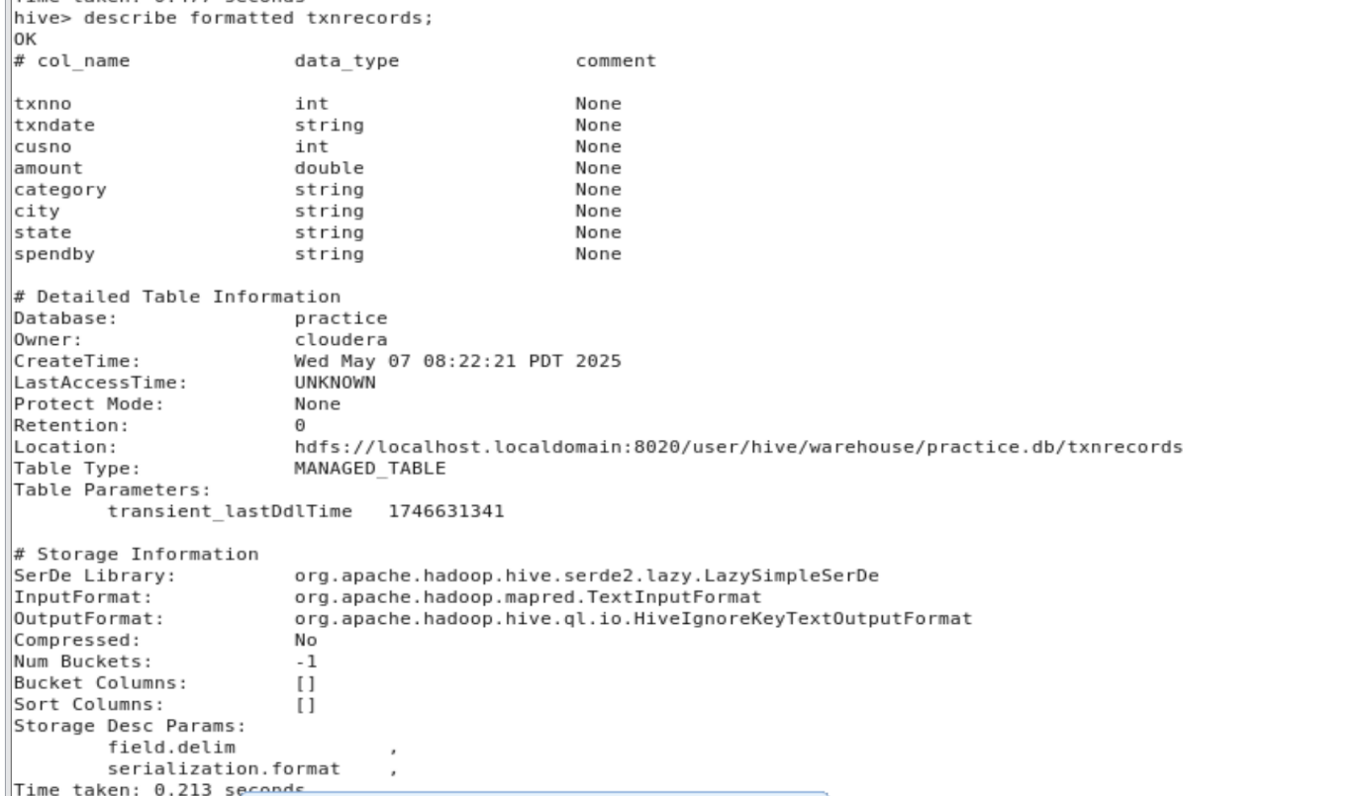

4. Finding number of records of a table
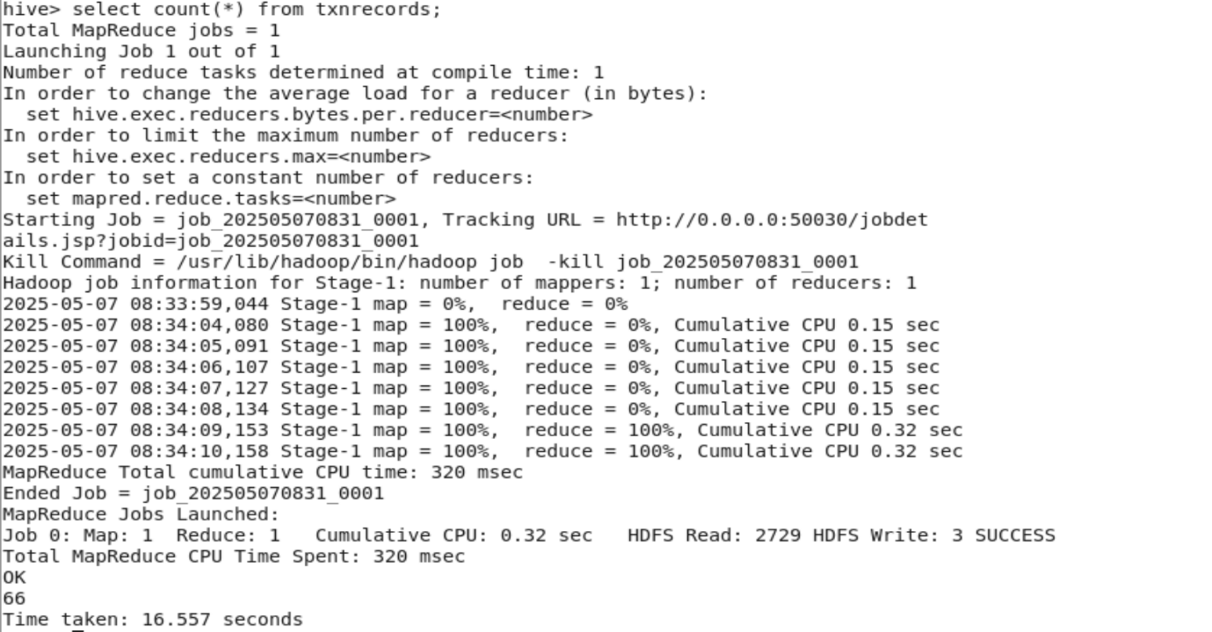
Copy from one table to another
1.create first table

2.Load data to first table
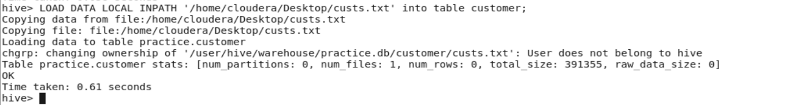
3.Create destination table

4. Copy the data from one table to another table using below command
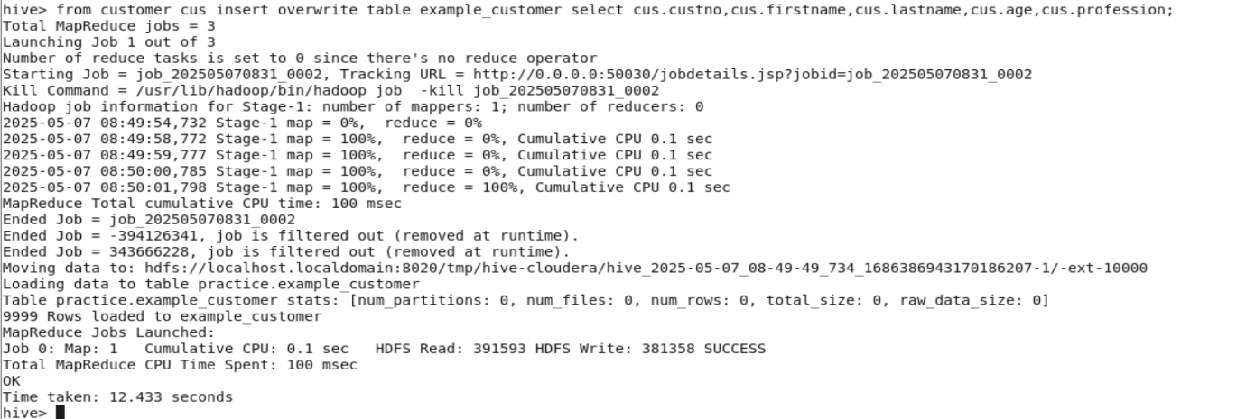

PARTITIONING
1.Create a table
2.Load the data from a file to table
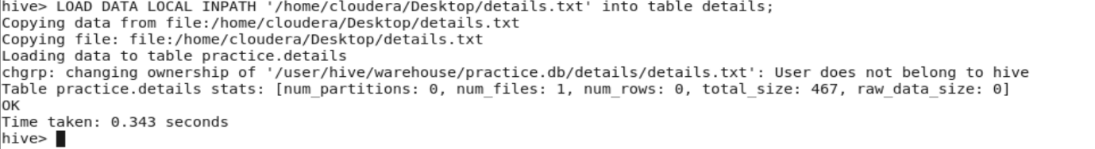
3.Create a partitioned table using below command

4. create a partition using the below commands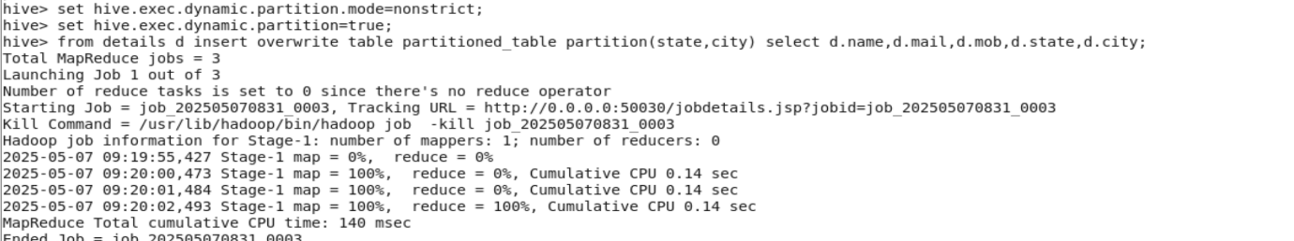

RESULTS
